Homework Assignment 10 Isaac Mather CS 3C

1. How does Dijkstra do with different sized mazes?
   * Its time complexity is better at smaller mazes, and begins to get worse as the maze size increases.
   * One of the things to note is the average % increase in time as the size of the maze doubles, for each doubling, aside from size = 20, we see a gradual decrease in performance, which indicates not quite quadratic time complexity. We can really see that in the bar graph below as well, there is a tremendous leap between maze size 80 and maze size 160. Interestingly enough, however, largest time complexity increase is from maze size 5 to maze size 10.

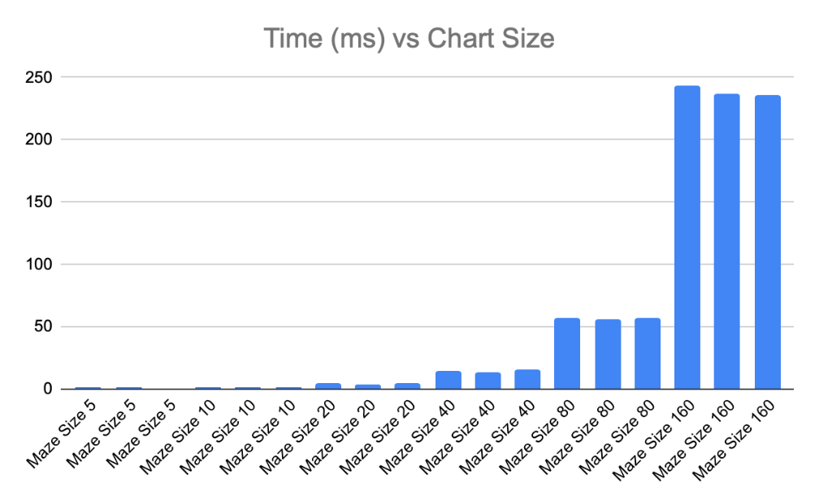

|  |  |  |  |
| --- | --- | --- | --- |
| **Size** | **Average Time** | **Average % Increase** | **% Increase of Average % Increase** |
| 5 | 0.81 |  |  |
| 10 | 1.20 | 149% |  |
| 20 | 4.39 | 364% | 244% |
| 40 | 14.16 | 323% | 89% |
| 80 | 56.23 | 397% | 123% |
| 160 | 238.60 | 424% | 107% |

1. Can you guess at a complexity?
   1. My guess at complexity is not quite N^2. I would guess at O(Nlog(N)). You really see as the size gets larger that the runtime increases.

1. Do you see any different results with STACK, RANDOM, or BIAS?
   1. We can see a trend in performance, in that BIAS and RANDOM are the top two performers, but not by a significant amount. We see that STACK never breaks in to the highest performing for any given maze size. Interestingly enough, BIAS is the best performer in the beginning at maze sizes 5 and 10, and then again at 160, but RANDOM takes the cake at sized 20, 40, 80. One interesting thing to note is that while STACK is never the top performer, it does beat out BIAS at size 40. Ultimately there isn’t a clear conclusive winner, these is plenty of variation in performance. One thing to note is that in create_and_solve(), my trials number = 20. There is some odd variation in increase in time complexity seen in the charts above, particularly in the upper left hand one, and increasing the number of trials could smooth out the increase in time complexity and give us a better understanding of the performance variations of the different types.

|  |  |  |  |  |  |  |
| --- | --- | --- | --- | --- | --- | --- |
|  | **Maze Size** | | | | | |
| **Type** | **5** | **10** | **20** | **40** | **80** | **160** |
| STACK | 1.124 | 1.549 | 4.932 | 14.177 | 56.65 | 243.236 |
| RANDOM | 0.762 | 1.052 | 3.662 | 13.136 | 55.404 | 236.994 |
| BIAS | 0.537 | 1.012 | 4.567 | 15.155 | 56.647 | 235.56 |

|  |  |  |  |  |  |  |
| --- | --- | --- | --- | --- | --- | --- |
|  | **Performance Compared to each other** | | | | | |
| **Type** | **5** | **10** | **20** | **40** | **80** | **160** |
| STACK | - | - | - | - | - | - |
| RANDOM | 32% | 32% | 26% | 7% | 2% | 3% |
| BIAS | 52% | 35% | 7% | -7% | 0% | 3% |